**Module 3 - HTML**

**Q-1. Are the HTML tags and elements the same thing?**

**Ans.** Tags and element is not the same thing.

Html tag is a container for some content or other html tag and html elements are component that are used in html tag. HTML document contains tag but do not contain element. An HTML element is defined by a starting tag. If the element contains other content, it ends with a closing tag.

For example <p> is starting tag of a paragraph and </p> is closing tag of the same paragraph but <p>This is paragraph</p> is a paragraph element

**Example :**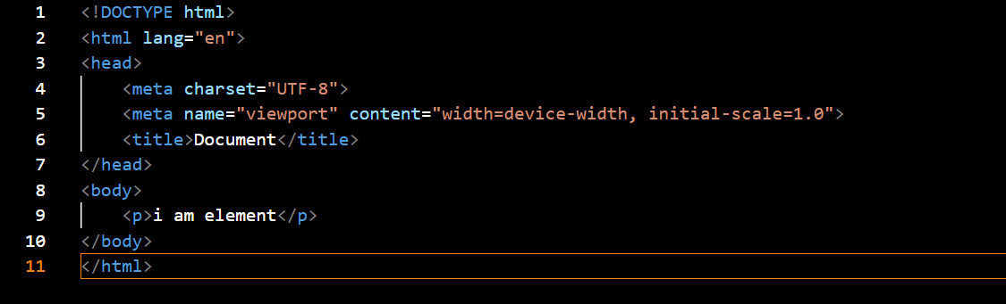

**Output :**

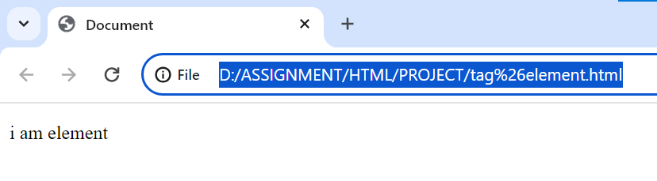

**Q-2. What are tags and attributes in HTML?**

**Ans.** html tag is a container for some content or other html tags. And html attributes are used to add more information on the tag attributes are instruction that clarify or modify element every element or tag can have attribute we can add multiple attributes in one html element attribute should always be used with the start tag. Some important attribute in html is

1. href attribute: we use a <a> tag to define hyper link in the <a> tag the href attribute specify the URL of the page link goes to.
2. Src attribute: We use the <img> tag add an image in an HTML page. The src attribute specifies the image path. We can specify the address of the image inside the double quotes.
3. Width and Height Attributes: The <img> tag also contains the width and height attributes. As the name suggests, these attributes specify the width and height of the image in pixels).
4. Atl attribute: The alt attribute is used with the image <img> tag. It helps us to specify the alternative text in case, the image cannot be displayed on the website. The alt attribute should reflect the image content so that users can understand what the image contains

**Example :**

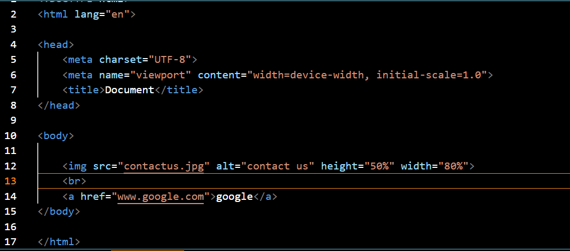

**Output :**



**Q-3. What are void elements in HTML? With Example.**

**Ans.** There is a special group of elements that only have start tags and does not contain any content within it these elements are called void elements Void elements doesn’t have ending tags and can only have attributes but do not contain any kind of content

Example of such element are <br>.<hr>,<img>,<input>,<col>,<area>

**Example :**

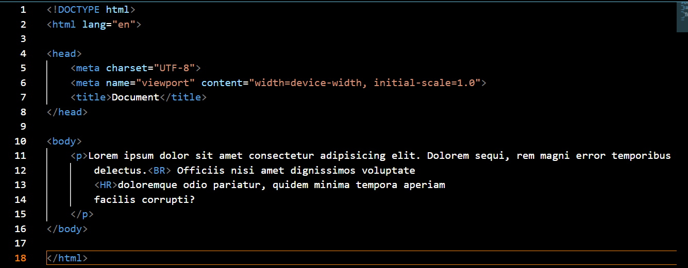

**Output :**

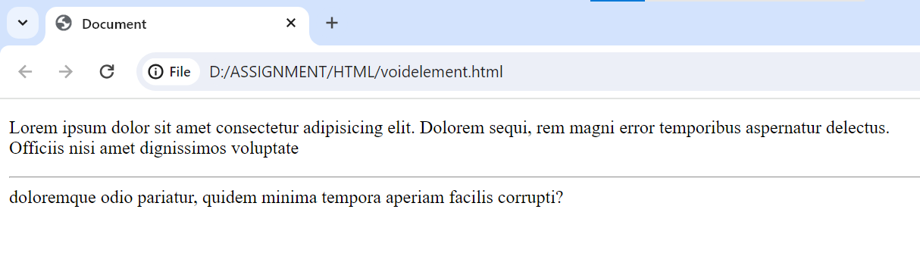

**Q-4. What are HTML Entities? With Example**

**Ans.** HTML entities are the reserved characters that have special meaning when used in an HTML document each of these code stars with ampersand and end with a semicolon example of such HTML entities are &#164; - use for currency

&#8482; - use for trademark

**Example :**

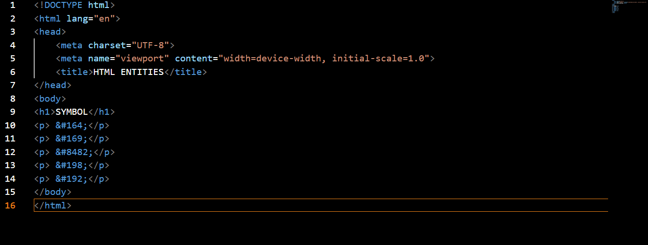

**Output :**

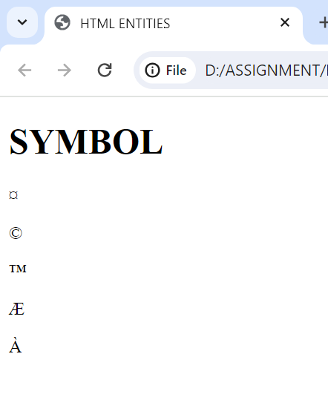

**Q-5. What are different types of lists in HTML? With Example**

**Ans.** There are three types of list in html

1. Ordered list (OL)

2. Unordered list (UL)

3. Description list (DL)

**1. ORDERED LIST**

In the ordered html list item are marked with number it is known as numbered list also the ordered list start with <ol> tag and the list item start with <li> tag.

**Example of ordered list** :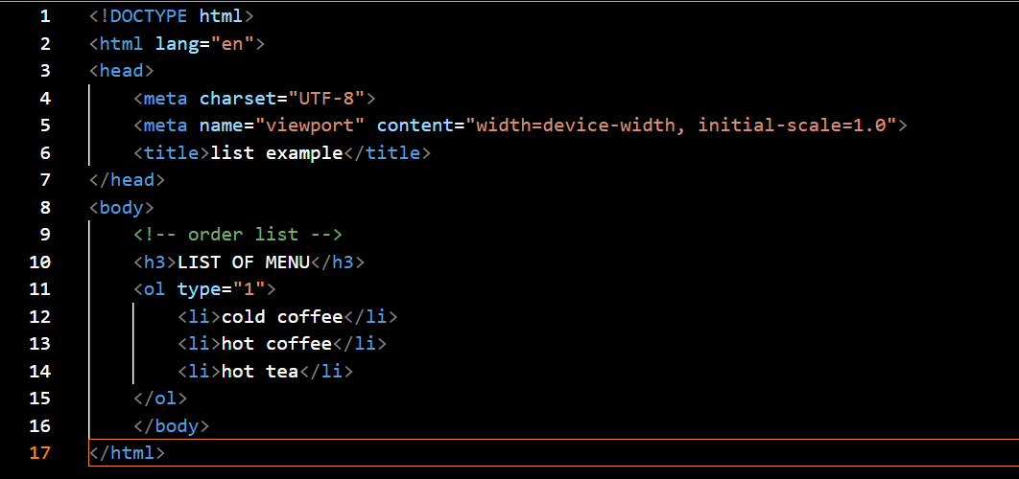

**Output :**

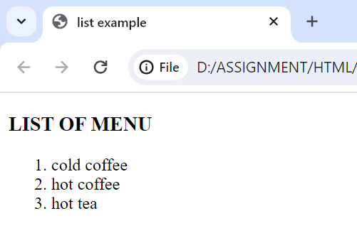

**2. UNORDERED LIST**

In html unordered list all the items are marked with bullets it is also know as bulleted list also the unordered list star with <ul> tag and list items start with <li> tag

**Example of unordered list :**

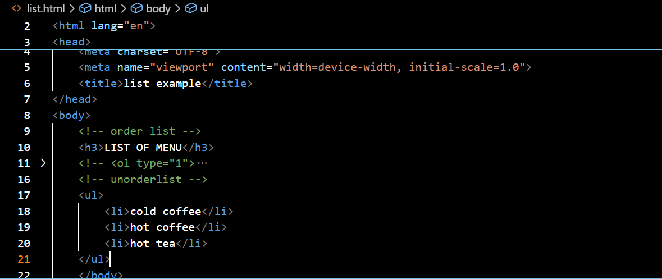

**Output :**

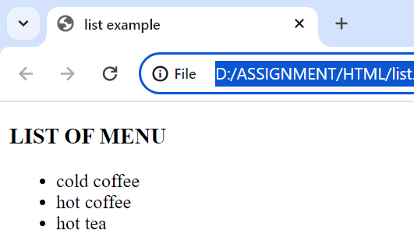

**3. DESCRIPTION LIST**

In html description list are used for lists of terms with their defination it is also known as definition list description list star with <dl> tag

**Example of description list :**

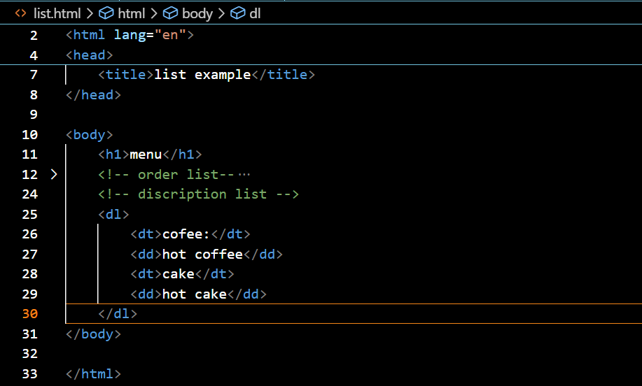

**Output :**

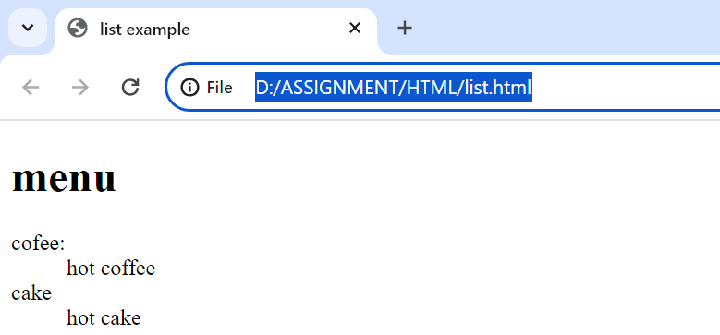

**Q-6. What is the ‘class’ attribute in HTML? With Example.**

**Ans.** The html class attribute is used to specify a class for and html element multiple html element can share the same class using the class attribute. The class attribute assigns one or more classnames to an element

**Example :**

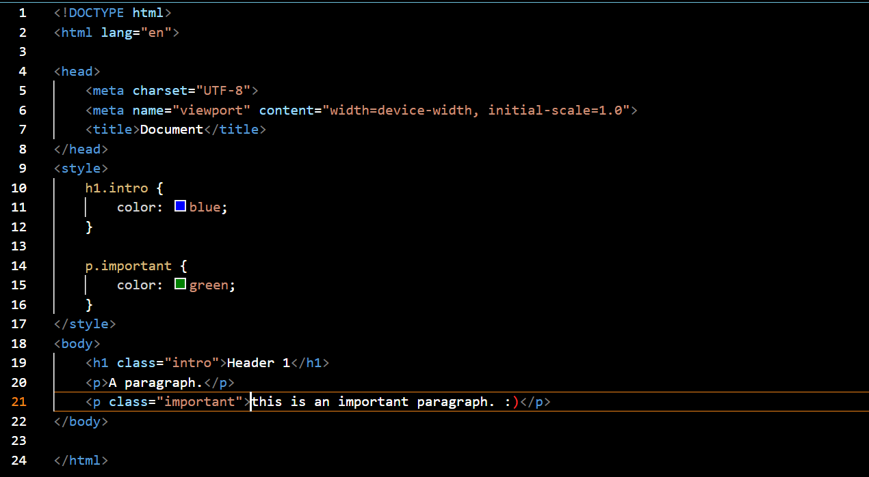

**Output :**

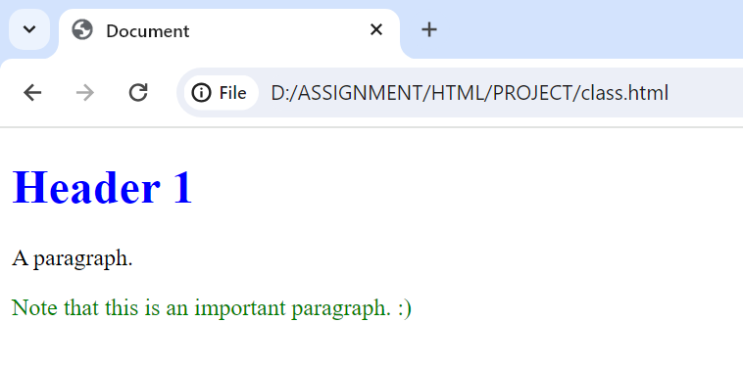

**Q-7 What is the difference between the ‘id’ attribute and the ‘class’ attribute of HTML**

**Elements? With Example**

**Ans.**

**id attribute:** The id attribute in HTML acts as a unique identifier for an element. It ensures that each element having an id is distinct from all others on the page. It’s like giving a specific name to an element, so you can refer to it uniquely. For instance, you might assign an id to a particular section of your webpage that you want to link to directly

**Class attribute:** On the contrary, the class attribute in HTML serves to identify multiple elements as belonging to a particular group or having a shared style. Think of classes as tags that categorize elements with shared characteristics. For instance, you might use a class to style all buttons on your webpage similarly

**Example :**

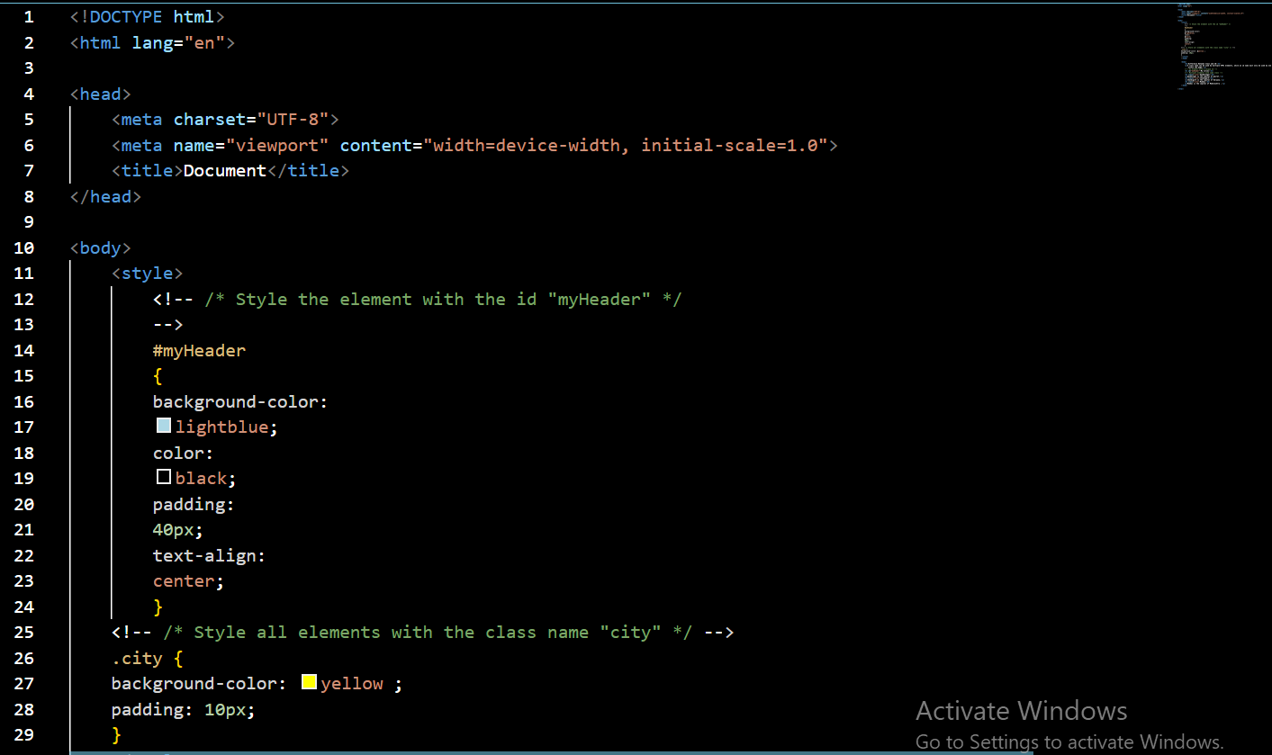

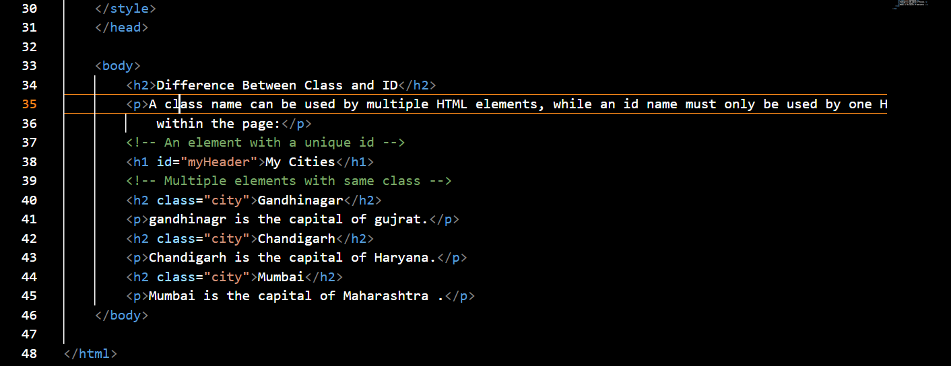

**Output :**

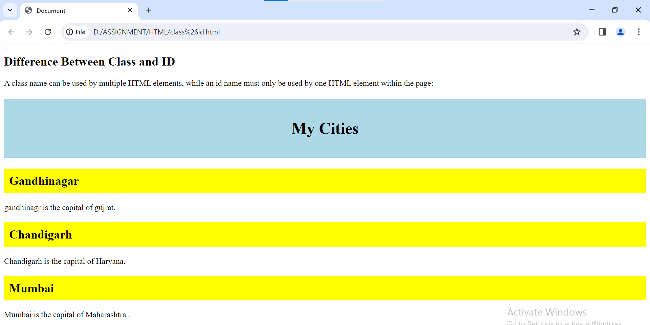

**Q-8. What are the various formatting tags in HTML?**

**Ans.** The formatting tag in html can used to change the font style ,size,color and other visual properties of text

Example of formatting tag is <b><i><u><strong><em><sub><sup><strike>  
**Example :**

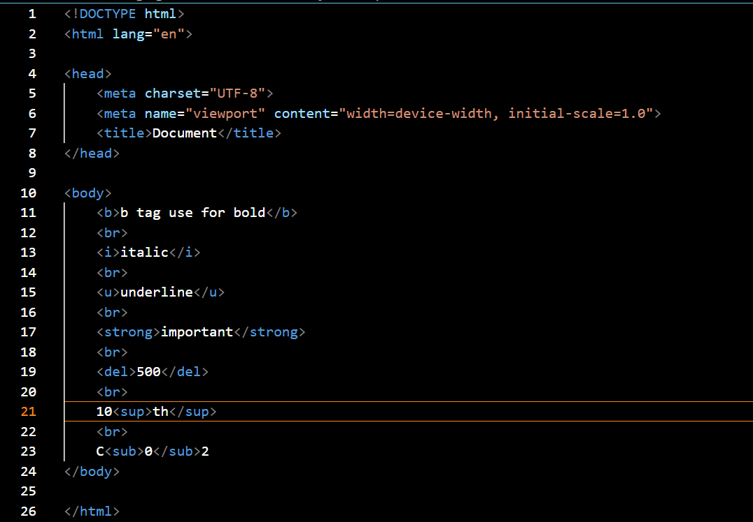

**Output :**

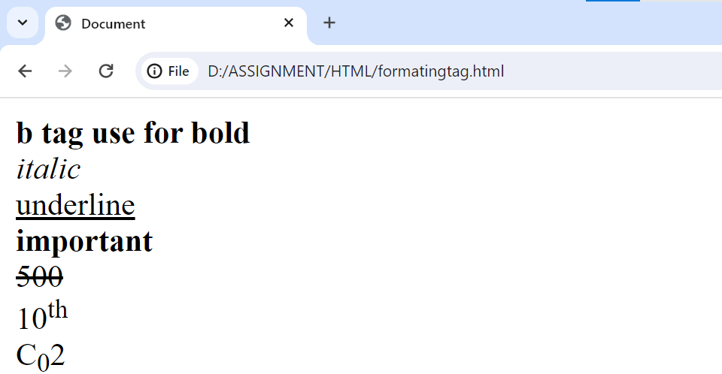

**Q-9. How is Cell padding different from Cell Spacing? With Example.**

**Ans.** Cell padding specifies the space between a cell's content and border cell padding defines the space that added between the content within a cell and cell's borders and

Cell spacing specifies the space between table cells it defines the space between the adjacent cells in table

**Example :**

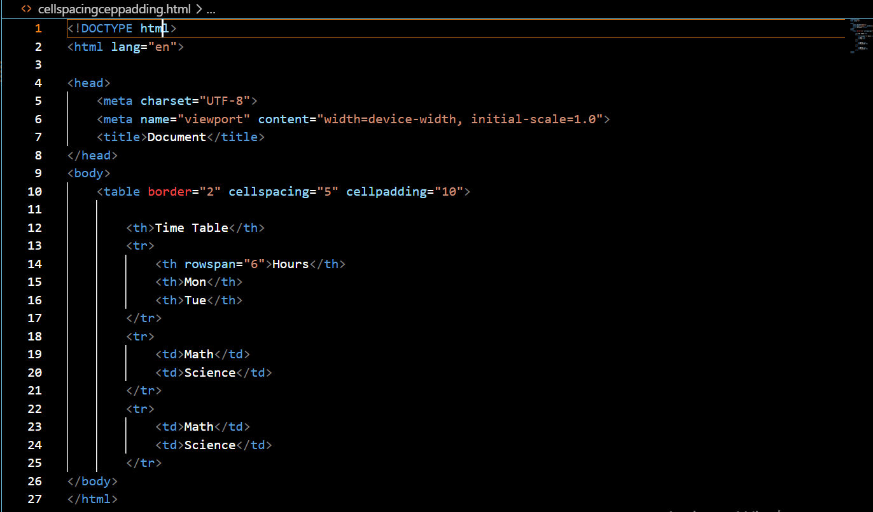

**Output :**

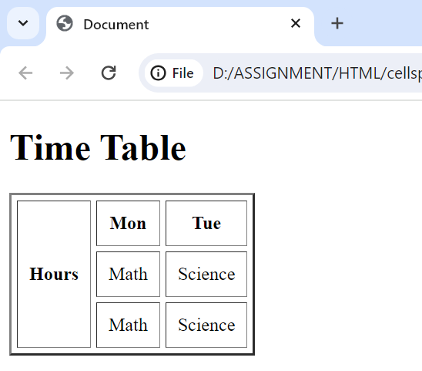

**Q-10. How can we club two or more rows or columns into a single row or column in an HTML**

**Table? With Example**

**Ans.** To merge two or more rows use the rowspan attribute and merge two or more column use the colspan attribute If you want to merge the first two cell in the first row you can use the rowspan attribute In first tag If you want to merge the first two cell in the first column you can use the colspan attribute In first tag.

**Example :**

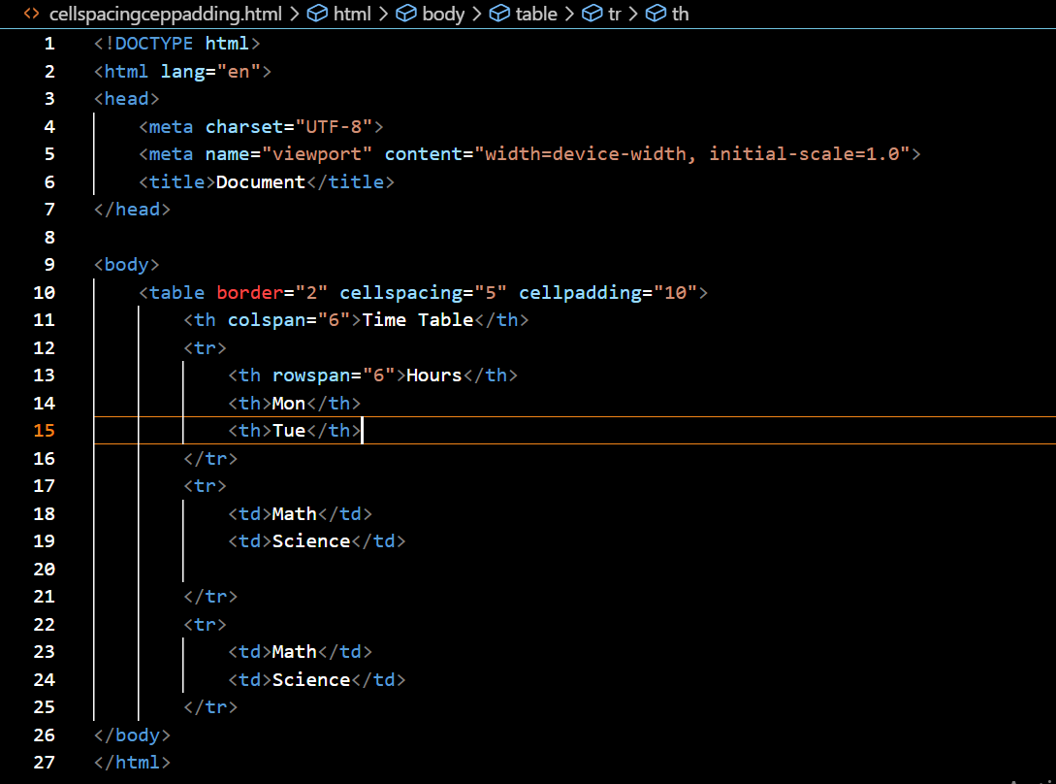

**Output :**

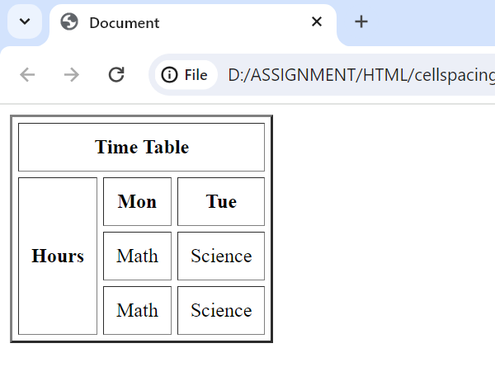

**Q-11. What is the difference between a block-level element and an inline element?**

**Ans.** The difference between block element and inline element is

**Block Level Elements** : Block level elements take up as much space as possible by default. Each block level element will start a new line on the page, stacking down the page. In addition to stackingvertically, block level elements will also take up as much horizontal space as possible

Examples of block level elements : <p>, <ol>, <ul> ,<dl> , <h1>to<h6> , <div>

**Example :**

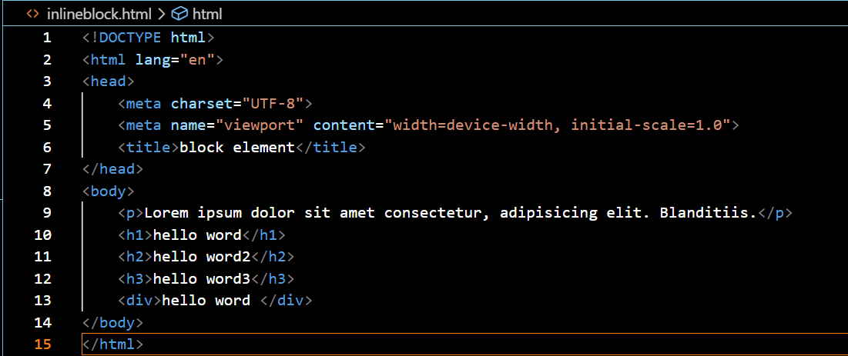

**Output :**

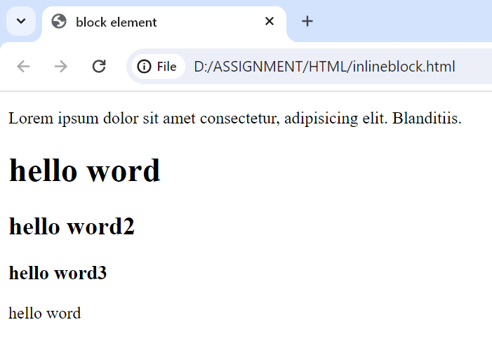

**Inline Elements** : Inline elements display in a line. They do not force the text after them to a new line.

Examples of block level elements : <a> , <strong> , <em> , <b> , <i> , <q> , <mark> , <span>

**Example :**

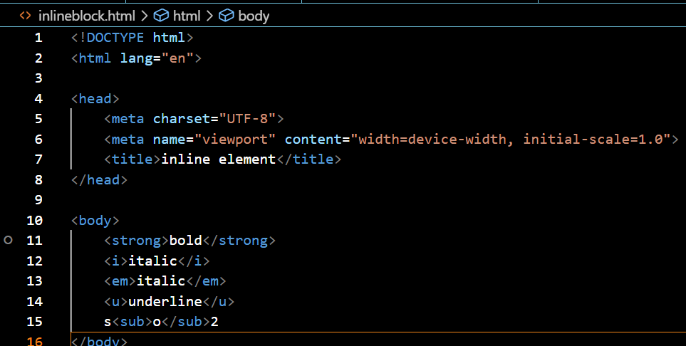

**Output :**

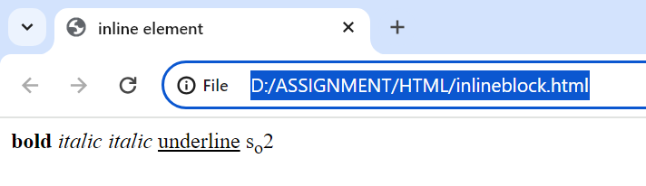

**Q-12. How to create a Hyperlink in HTML? With Example**

**Ans.** To insert a hyperlink in a HTML page, we have to utilize the anchor tags <a> and </a>, Labels, which are used to characterize the connections. The <a> tag demonstrates where the hyperlink begins and the < / a> tag shows where it closes. Whatever text gets added inside these labels, will function as a hyperlink. Add the URL for the connection in the

<a href = " ">

**Example :**

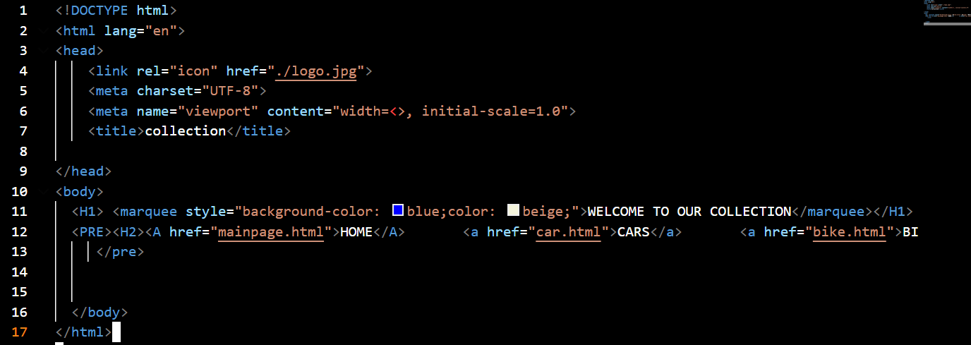

**Output :**

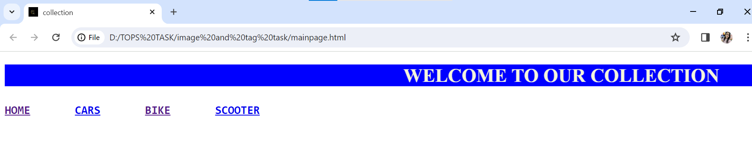

**Q-13. What is the use of an iframe tag? With Example**

**Ans.** To use an iframe in HTML, create an iframe element and define its characteristics, such as the content’s source, width, and height, as well as a name to identify the iframe. You can also use CSS styles to change the appearance of the iframe. Once the iframe is in place, you can load any form of material from a different source into your web page, such as a movie, a map, or even a social media feed

**Example :**

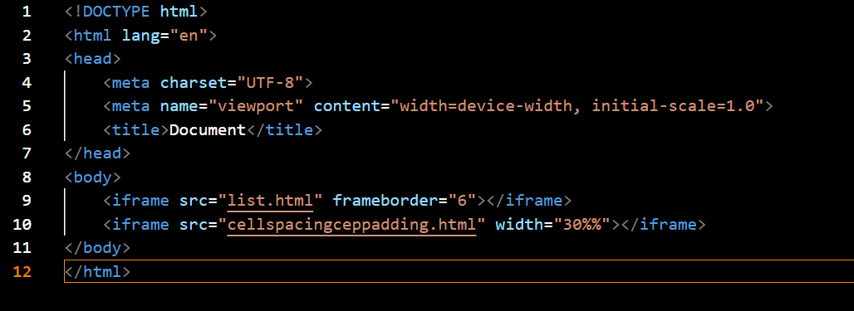

**Output :**

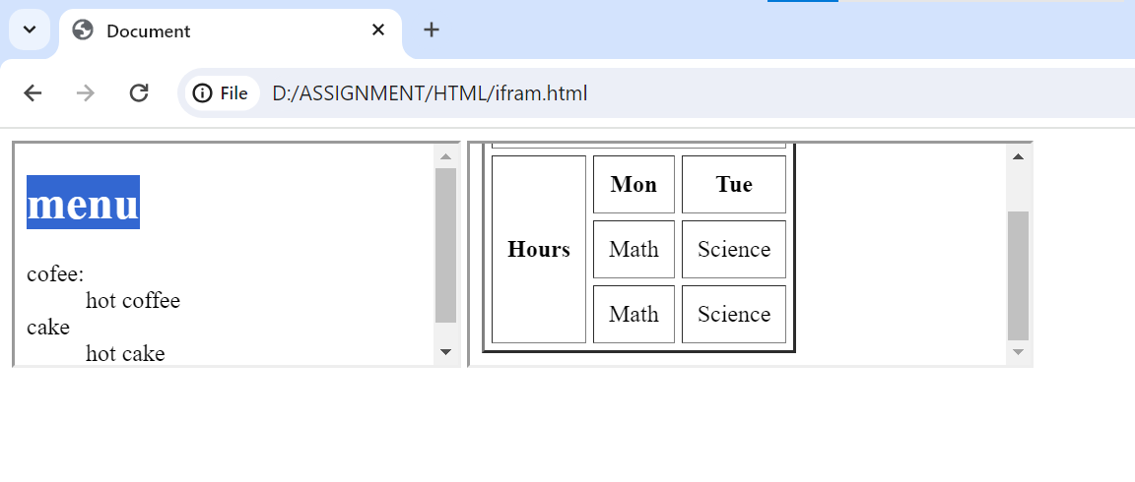

**Q-14. What is the use of a span tag? Explain with example?**

**Ans.**  HTML <span> tag is used as a generic container of inline element it is used for styling purpose to the grouped inline element

The <span> tag does not have default meaning

Html <span> tag is much similar as <div> tag but <div> tag used for block level element and <span>tag is used for inline element

**Example :**

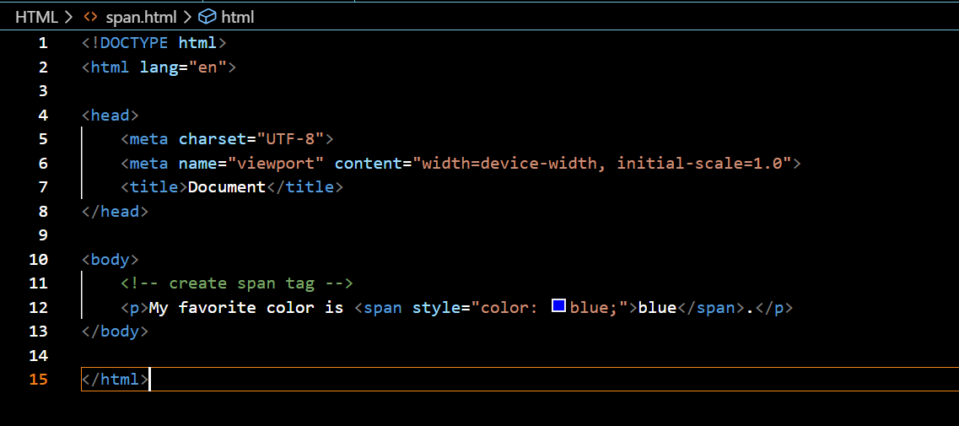

**Output :**

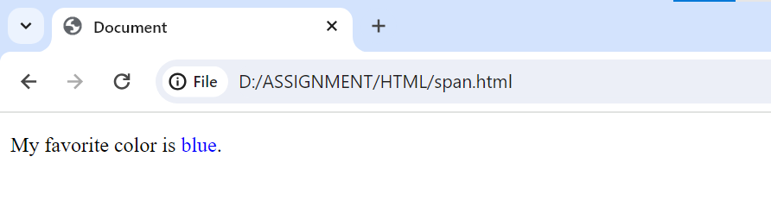

**Q-15. How to insert a picture into a** background **image of a web page? With Example**

**Ans.** the use the background attribute in the body tag to set an images as the background of webpage we will need to specify the URL or the location of the image which we want to set to the background attribute of the body tag

**Example :**

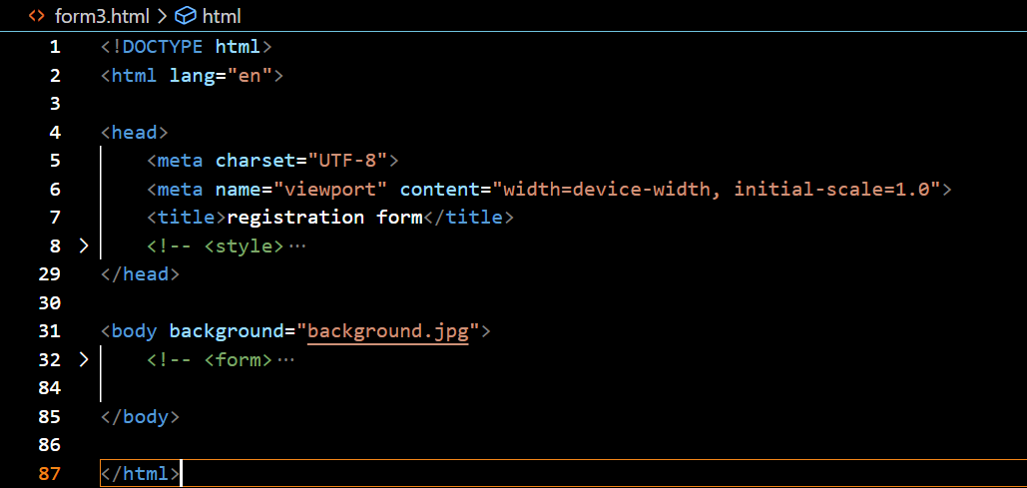

**Output :**



**Q-16. How are active links different from normal links?**

**Ans.** A normal link is just a line of code that contains a pointer to another resource. An active link is that line of code in action, opening that other resource.

**Normal Link Example:**

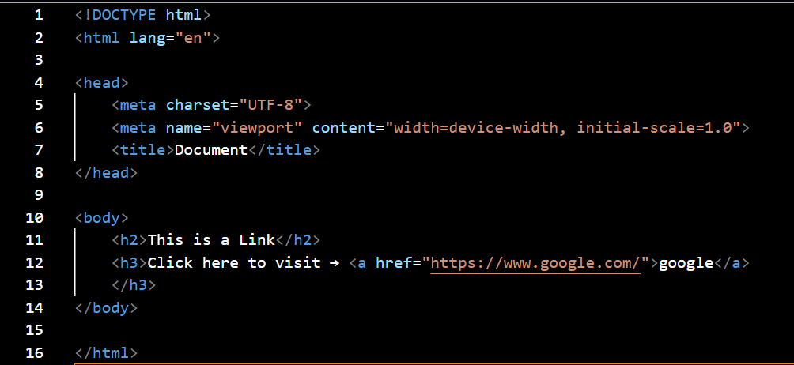

**Normal Link Output :**

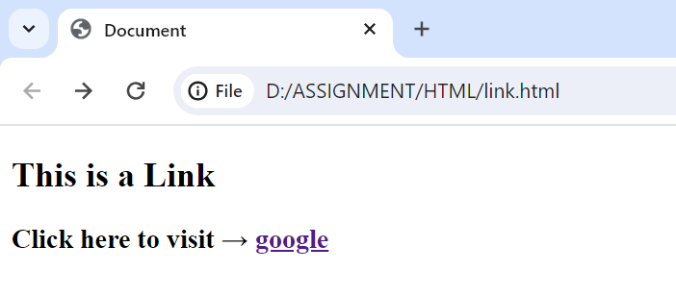

**Active link Example :**

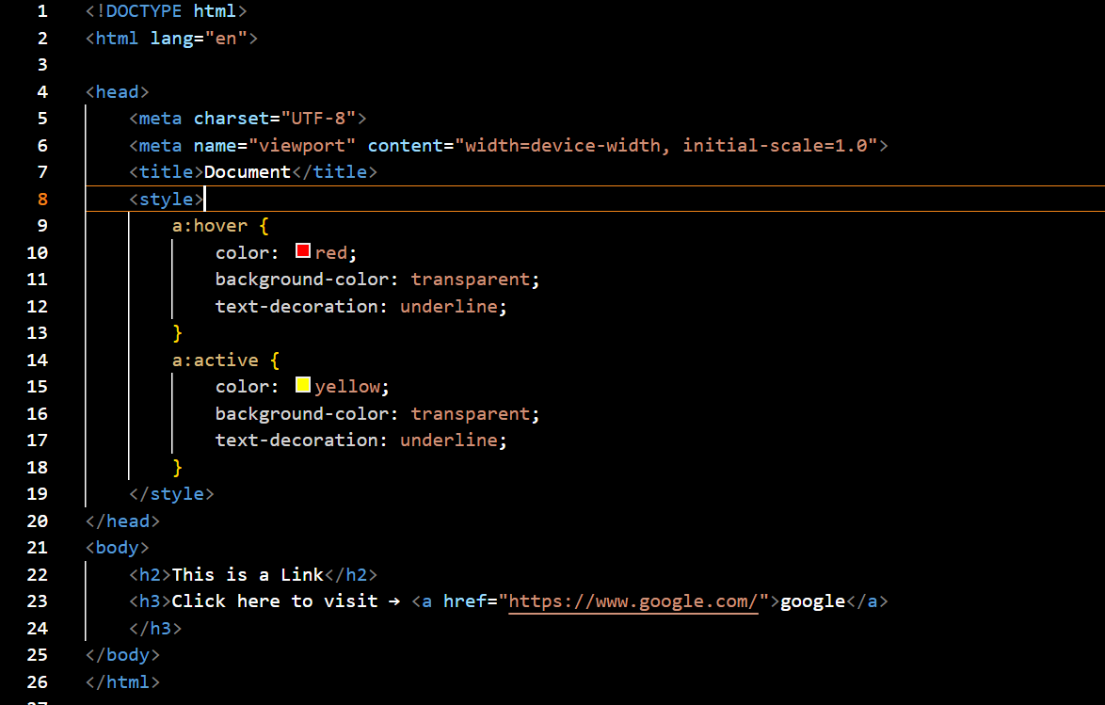

**Active link Output :**

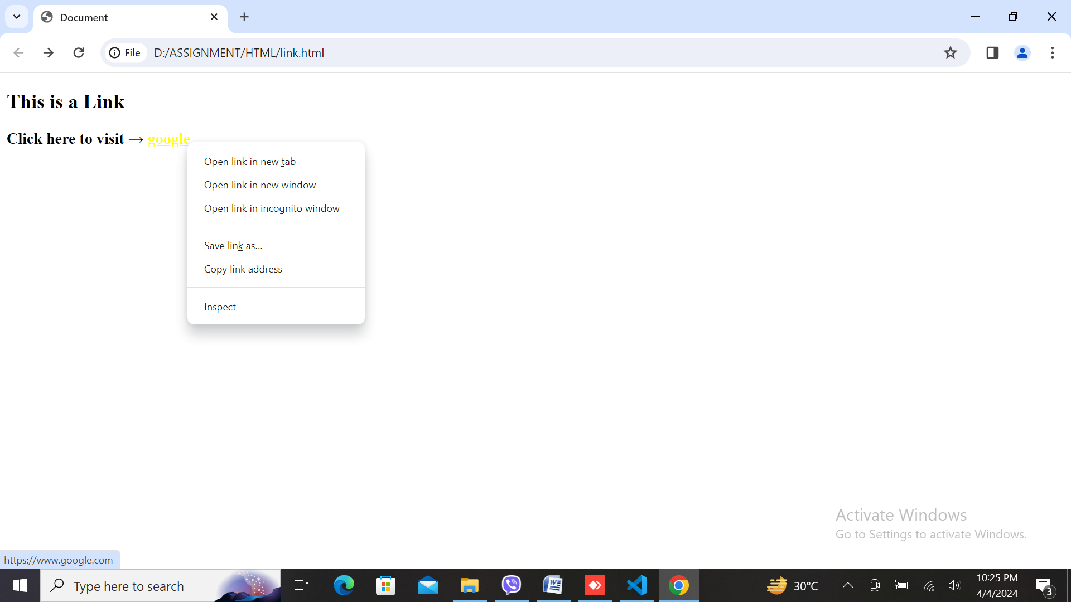

**Q-17. What are the different tags to separate sections of text?**

**Ans.** The <br> tag is one way to separate the lines of text. There are other tags like the <p> tag and <blockquote> tag that are also used to separate sections of text

**Example :**

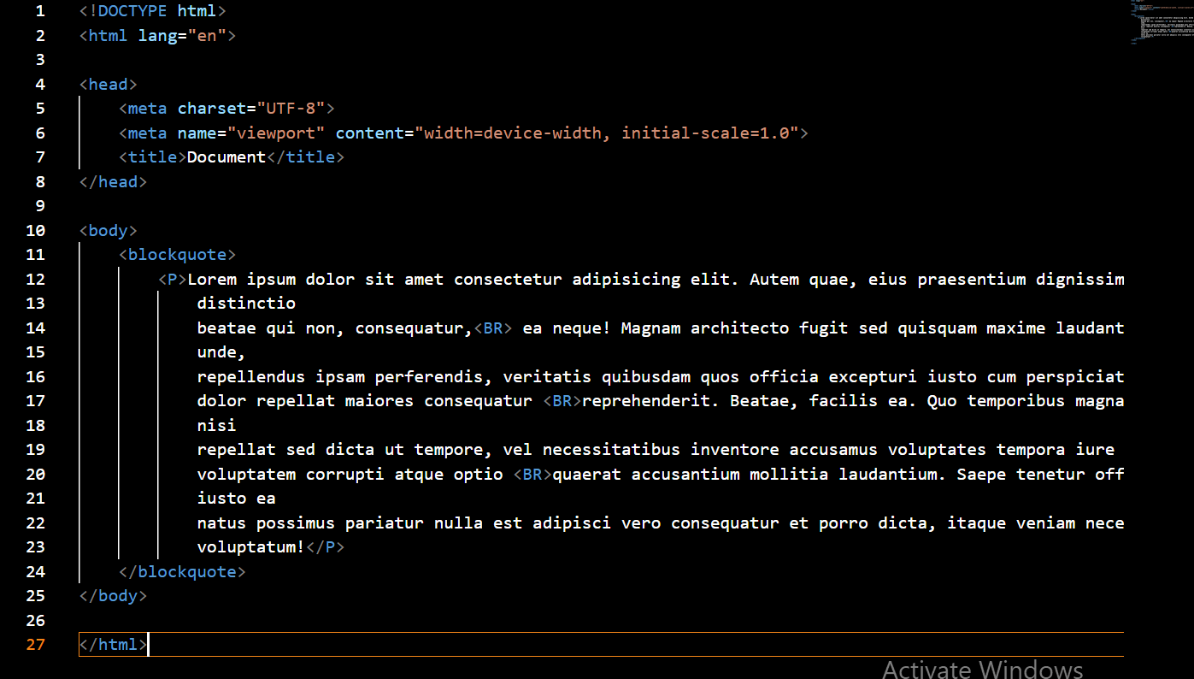

**Output :**

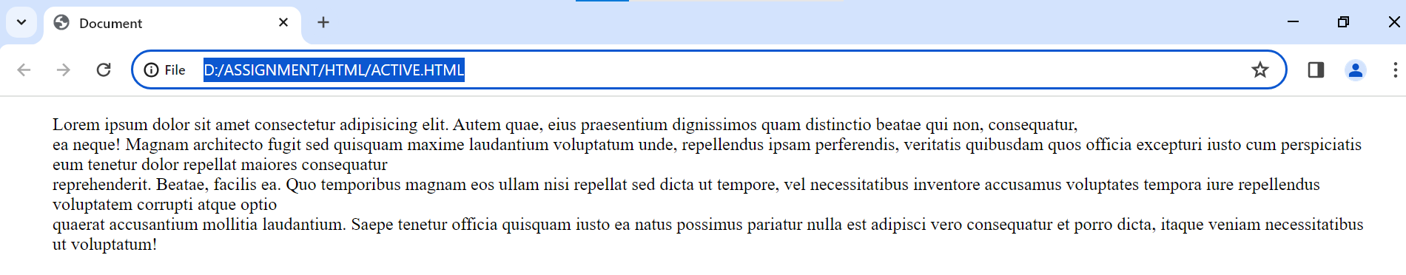

**Q-18. What is SVG?**

Ans-SVG stands for scalable vector graphic

SVG define vector based graphic in XML format

SVG graphics are scalable ad do not lose any quality if they are zoomed or resize

SVG has elements and attributes for rectangles, circles, ellipses, lines, polygons, curves, and more

A simple SVG document consists of the <svg> root element and several basic shape elements that will build a graphic together

**Example :**

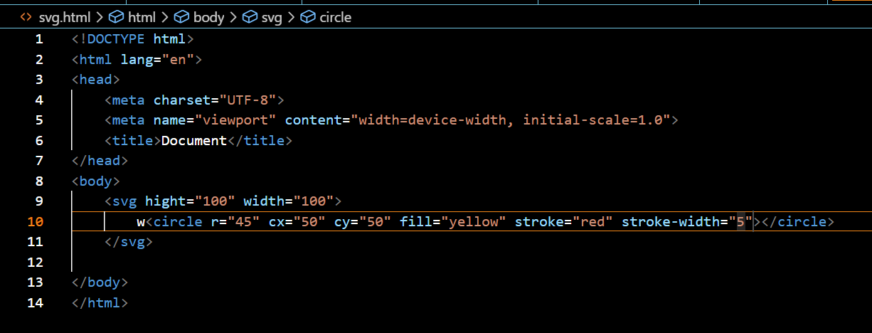

**Output :**

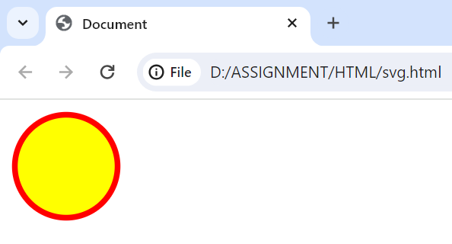

**Q-19. What is difference between HTML and XHTML?**

**Ans.**

HTML stands for hyper text markup language whereas

XHTML stands for extensible hyper text markup language

HTML is an SGML base language SGML stands for standard generalized markup language

XHTML is an XML based language which means it manipulated and processes data using XML technologies

HTML is not case sensitive language

XHTML is a case sensitive language

Some HTML element may function properly without a closing tag

All the XHTML element must be closed even the empty elements also require closing tag

HTML file name extension of .html .htm

XHTML file name extension can be .xhtml, .xht or .xml

**Q-20. What are logical and physical tags in HTML?**

**Ans.**

**Logical tag:** logical tags are used to tell the browser what kind of text is written inside the tag .logical tags are also known as structural tags because they specify the structure of the document logical tags can be used for styling purposes as well as to give special importance to text contentSome logical tag are <blockquote> , <del> , <ins> , <pre> <samp><strong>

**Physical tag:** physical tag are used to indicate that how specific character are to be formatted or indicate using HTML tag any physical style tag may contain any item allowed in text including text images , line breaks etc. Physical tags can be used for styling purpose for specific element Some physical tag are < sup> <sub> <i> <b> <u> <strike>

**Example :** 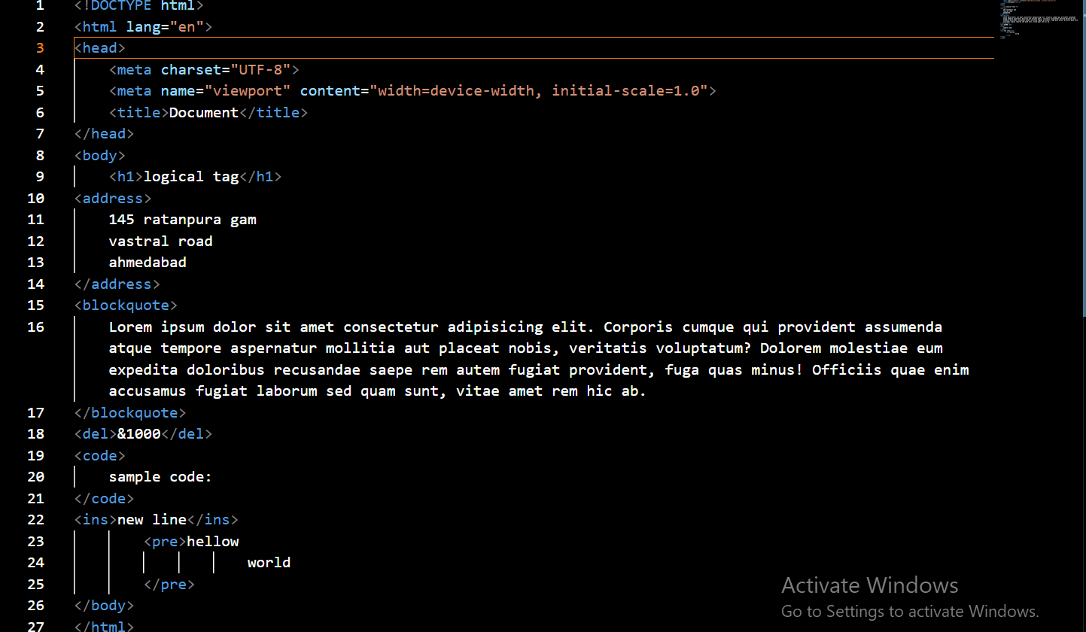

**Output :**

